GHA Upper School 2024-2025
Proposed plan, subject to change.*
Traffic Flow for Drop-Off and Pick-Up
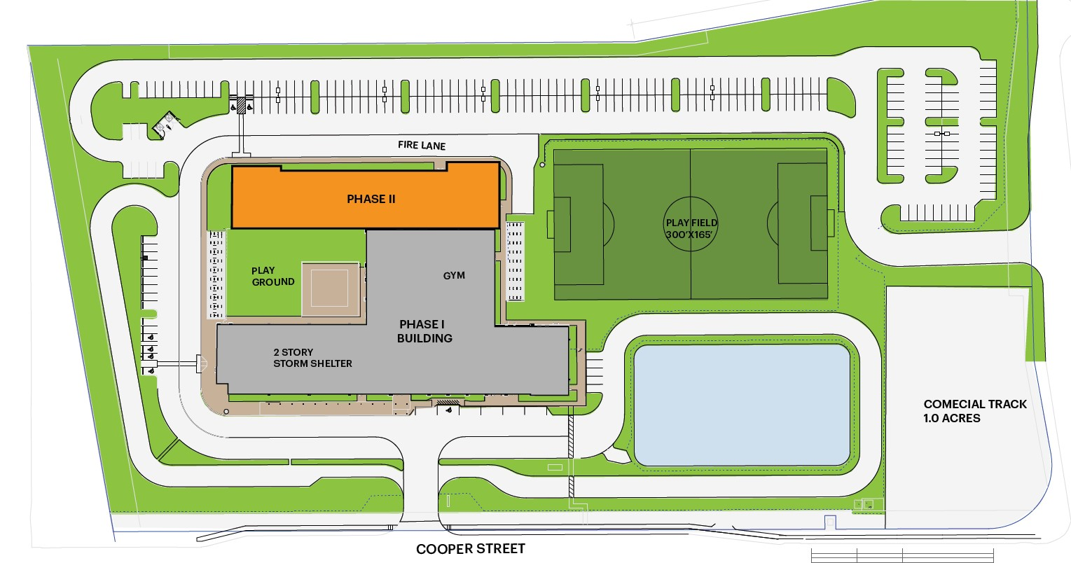
Eden Gate Only
CONSTRUCTION AREA
EDEN ROAD
Upper School Daily School Schedule
Monday-Thursday 8:15am-4pm
Early Release Fridays 8:15am-2pm
Student Entrance

2-Way Traffic
CONSTRUCTION AREA
LOADING AREA
CONSTRUCTION PARKING ONLY
CONSTRUCTION
OFFICES

Faculty Parking Only
Morning Carline will be from 7:50am-8:10am. Afternoon Carline will be from 4pm-4:25pm. (Early Release Fridays 2pm-2:25pm)
*Lower School siblings will wait in the MPR until their Upper School sibling is dismissed. Students from the same family will walk out to carline together. We strongly encourage sibling pickup between 4pm-4:10pm.

